Step up to Sixth Form

* Bridging the gap between school and college

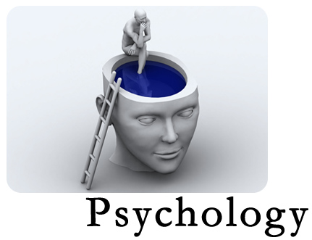**What is Psychology?**

The purpose of this booklet is to introduce you to some of the topics that we cover in a level 3 Psychology course.

The intention is that you will complete some basic research on what Psychology is and then complete some work that relates to key researchers that have investigated human behaviour over the last 120 years and then focus on looking at specific areas of the subject that we consider to help us explain behaviour.

If you are interested in the subject of Psychology then we would expect that you will find this research interesting and will bring your completed booklet with you when you start on the course in September.

If you have any questions or would like further information about the course or any particular topics you are interested in, please feel free to email me at:

kathryn.port@hartlepoolsixth.ac.uk

Step into Psychology

– the basics……...

Name:

1. Write a definition of what Psychology is?





2. What behaviours do psychologists study?

3. What fields of work do psychologists get involved in?

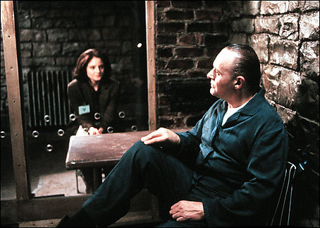



4. What jobs can I do if I study Psychology?

<https://www.bps.org.uk/>

<https://www.verywellmind.com/a-list-of-psychology-careers-2794917>

**Key researchers in Psychology**

**Carry out an internet/book search of the following key historical figures in Psychology and briefly summarise what they contributed to our understanding of human or animal behaviour**

|  |  |  |
| --- | --- | --- |
| **Psychologist** | **Timeline** | **Key area of Psychology and research** |
| Sigmund Freud |  |  |
| John Watson |  |  |
| Burrhus Skinner |  |  |
| Stanley Milgram |  |  |
| Phillip Zimbardo |  |  |
| Laurence Kohlberg |  |  |
| Albert Bandura |  |  |
| Elizabeth Loftus |  |  |

**Looking at some of the topics we study in Psychology**

**Left and Right Brain function**

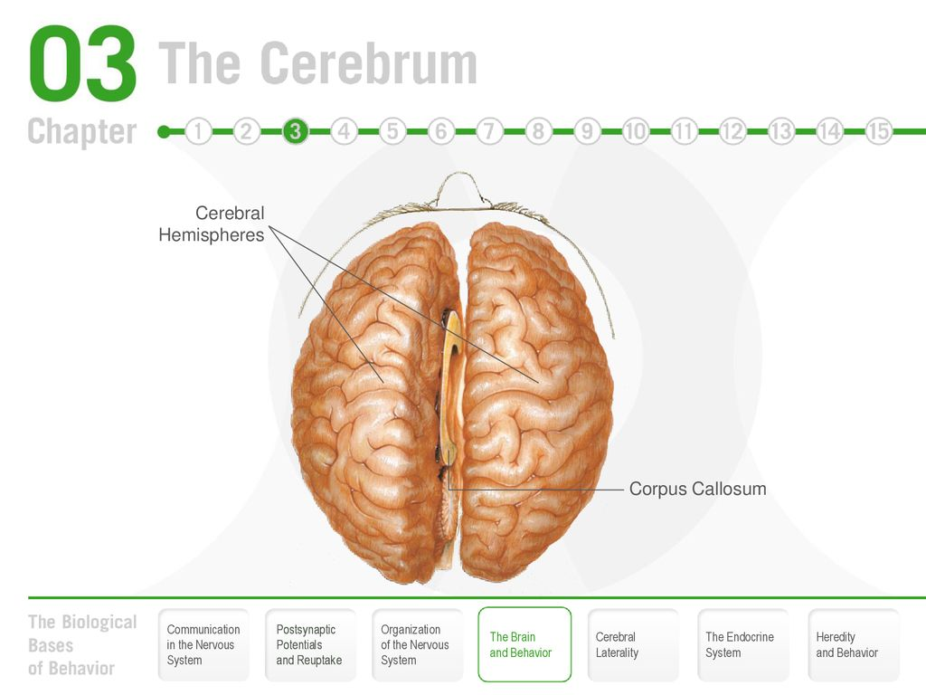[](https://www.google.co.uk/url?sa=i&rct=j&q=&esrc=s&source=images&cd=&cad=rja&uact=8&ved=0CAcQjRxqFQoTCMTryK_3h8YCFeoW2wodS_IAZQ&url=https://at37.wordpress.com/2014/07/25/mandalas-help-unlock-the-real-secret-to-the-secret-which-is-learning-about-outsmarting-the-left-brain/&ei=DKZ5VcS1Fuqt7AbL5IOoBg&bvm=bv.95277229,d.ZGU&psig=AFQjCNFO-AGt_-vV9DiBGd2Ic4yYksQx3A&ust=1434122101128352)Our brains have two main hemispheres – on the left and right sides. These left and right hemispheres have been found to have some specialised behavioural and biological functions.

In psychology this theory is based on the **lateralisation** of brain function. The right brain-left brain theory originated in the work of **Roger W. Sperry**. While studying the effects of epilepsy, Sperry discovered that cutting the corpus callosum (the structure that connects the two hemispheres of the brain) could reduce or eliminate seizures.

Research work done by Roger Sperry and Michael Gazzaniga identified some of the behaviours, functions or abilities that are associated with either the left or right side of the brain.

Research the functions of the different sides of the brain and write them into the relevant boxes below.

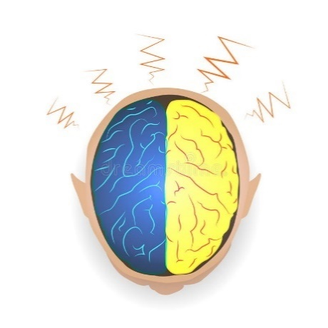

RIGHT BRAIN FUNCTIONS

LEFT BRAIN FUNCTIONS



[Course link: Core study: Sperry (1968) Hemisphere deconnection

You can read more about the left and right hemisphere and the corpus collosum here:

<https://www.neuroscientificallychallenged.com/blog/know-your-brain-corpus-callosum>

**Self – control**

Why are some people able to resist temptation and others find it harder?

Is self-control something we learn or is it a biological function?

Put your own thoughts here…….

Walter Mischel in his Marshmallow study suggested that self-control might be a characteristic that develops in childhood and remains a relatively stable characteristic over time and is linked with brain functioning

Read about the ‘Marshmallow study’ here:

<https://www.psychbytes.com/marshmallow-test-delay-of-gratification/>

Summarise what you learn in the box below:

**Course link: Core study: Casey (2011)– Neural correlates of delay of gratification**

**Mental Health Disorders**

One of the areas psychologists’ study is mental health. They are interested in how disorders are diagnosed, what causes them and how they can be treated.

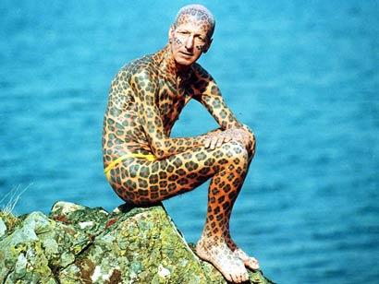They also discuss what behaviours are considered normal or abnormal and how accurate diagnosis is. Consider the following questions:

What is ‘abnormal’ behaviour?

What is ‘normal’ behaviour?

In what ways do we differ from each other?

What affects what sort of person you are? (your personality)

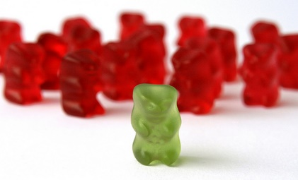

Is intelligence level inherited (genetically linked) or learned?

**Psychopathy** is a type of Mental Health personality disorder where an individual will often prey ruthlessly on others using charm, deceit, violence or other methods that allow them to get what they want.

Psychopathy characteristics can be measured using questionnaire checklist such as the PCL-R developed by Robert Hare.

Read about Robert Hare’s work and psychopath checklist here:

<https://www.cbc.ca/doczone/features/the-hare-psychotherapy-checklist>

A number of key people in history have been identified as having psychopathic personality characteristics.

If you delve into the lives of some of the most interesting and influential characters in history you will find that the presence of psychopathic traits was critical to their success.

## Out of the following people can you guess who scored most highly on a test of psychopathy?

Charles Dickens; Adolf Hitler; Winston Churchill; Oscar Wilde; Freddie Mercury; William Shakespeare; Isaac Newton; Margaret Thatcher.

<http://psychopath.channel4.com/quizzes.html#test1>

**Course link: Core study: Hancock (2011): The Language of Psychopaths**

**Environmental**

Researchers like Albert Bandura believe that we learn to be aggressive by watching other people like our parents, siblings and media role models. This approach suggests that watching violence on TV/ films/ DVDs is dangerous especially where characters are seen to profit from their aggressive behaviour. The photographs opposite are from his classic experiment from 1965.

MCj03392140000[1]**What do students’ learn in Psychology?**

**Component 1 – Research Methods**

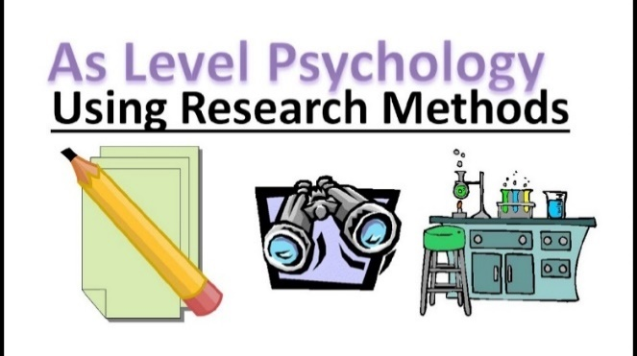You will learn about how psychologists’ study human behaviour using different methods of investigation including:

Self-Reports – asking people

Observations – watching people

Experiments – testing people

Correlations – looking for relationships and links

You will learn the strengths and weakness of the above methods of research and also how data collected during research can be analysed, compared and conclusions made.

**Component 2 – Core Studies through Psychological Themes**

You will also learn **20 key research studies** from the history of psychology and look at their impact on our understanding of behaviour. There are 4 studies for each of the five main areas of psychology which take a different approach to explaining behaviour.

|  |  |  |  |  |
| --- | --- | --- | --- | --- |
| **Cognitive Psychology** | **Developmental Psychology** | **Physiological Psychology** | **Social Psychology** | **Individual differences** |
| **Eyewitness testimony**  (Loftus and Palmer) | **Aggression** (Bandura and Ross) | **Hemisphere deconnection**  (Sperry) | **Obedience to authority**  (Milgram) | **Phobias**  (Freud) |
| **Context dependent memory**  (Grant) | **Positive reinforcement and adherence**  (Chaney) | **Neural Correlates and delay of gratification**  (Casey) | **Obedience/ disobedience and Whistleblowing**  (Bocchiaro) | **Autistic Spectrum disorder and Theory of Mind**  (Baron- Cohen) |
| **Auditory attention**  (Moray) | **Moral Development**  (Kohlberg) | **Visual Cortex development in kittens**  (Blakemore) | **Bystander behaviour**  (Piliavin) | **A nation of morons**  (Gould) |
| **Inattentional blindness**  (Simons & Chabris) | **Children’s judgments of lies and truth-telling**  (Lee) | **Taxi Drivers brains**  (Maguire) | **Cultural differences in helping behaviour**  (Levine) | **The Language of Psychopaths**  (Hancock) |

**Component 3 – Applied Modules in Psychology**

In the second year of study you will complete 3 modules of applied psychology looking at how psychology is used in everyday life and consider practical applications of psychological knowledge. The three applied modules are:

**Issues in Mental health** – What it means, what are the causes of disorders and how mental health issues can be treated

**Child Psychology** – how children develop emotionally, socially, cognitively and physiologically.

**Criminal Psychology** – what makes a criminal, forensic evidence, investigations, courtroom procedures and punishment and rehabilitation.

**Exams**

There are **three** exam modules – one for each of the 3 components – all taken at the end of the second year.Find out more about psychology and the course here: <https://www.hartlepoolsixth.ac.uk/courses/school-leaver/>

and here:<https://www.ocr.org.uk/qualifications/as-and-a-level/psychology-h167-h567-from-2015/>