Get Ahead!
Health and Social Care Activity Booklet

Name:

School:

Career goal:

In light of recent events, we are even more so grateful to have our fantastic National Health Service. This section in the booklet will focus on the NHS, the people who work within it and the fantastic services it offers.
You may need to complete some further research to complete some activities. You will find a list of recommended websites at the end of the booklet.
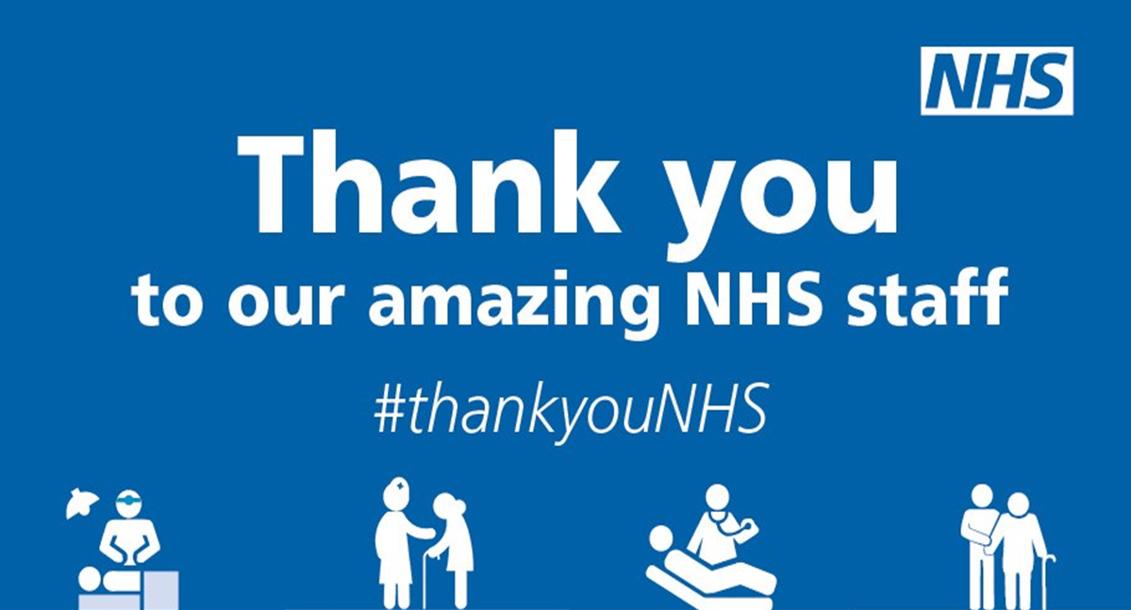
Activity 1
Complete on the following page.
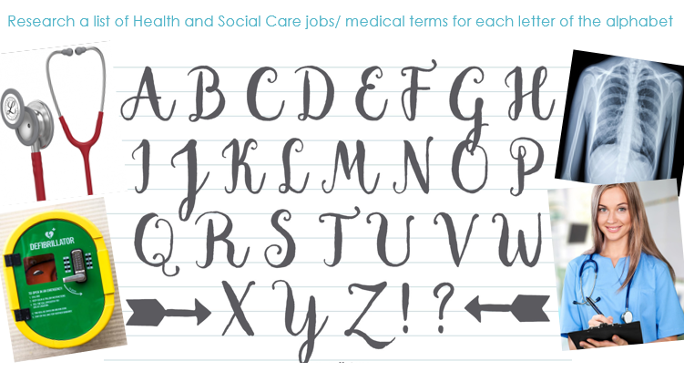

A -
B -
C -
D -
E -
F -
G -
H -
I -
J -
K -
L -
M -
N -
O -
P -
Q -
R -
S -
T -
U -
V -
W -
X -
Y -
Z -

Activity 2
You may need to complete some further research to help with this activity, see the website list to help you.

Job Role | Where may you find an individual of this role working? (eg. Hospital) | Roles and responsibilities  (eg. Assisting with meals)
Nurse
Midwife
Doctor
Healthcare Assistant
Occupational Therapist
Social Worker
Youth Worker
Support Worker

Activity 3
It is important to remember that we did not always have access to a National Health Service. This activity includes research into the history of the NHS and how it came into being.
Your task to complete this activity is to write a short report in the box below.
You could look at:

- Life before the NHS. Workhouses and the poor law.
- The Beveridge Report
- The work by the Labour Government and the then Prime Minister - Clement Attlee and Aneurin Bevan
- The year the NHS was implemented, the cost of the services and issues faced
- A comparison of pre NHS to modern times
- Any other research you find interesting or appropriate
Websites below to help

Activity 4
The use of media sources to raise public awareness
Some of the programmes and books cover sensitive topics, we suggest you look at the topics and concepts included before you watch/read and ensure you are comfortable to continue.
Your task is to choose
- 3x Movies
- 1x Book

After reading or watching the different forms of media you have chosen; write a report on the question below.

‘Discuss the portrayal of Health and Social Care within the media’

You could consider the following;
- What issue or issues does this form of media cover?
- How does this form of media present Health and Social Care issues?
- Is the form of media informative/helpful in the issues it presents?
- Are there any quotes or specific scenes that stand out to you, why?
- Do you believe this form of media is effective in raising public health awareness of health and social care issues?
You can include any other aspects you feel relevant.

Report:

Activity 5

Anatomy of the body - Blood Vessels
For this section; you might want to complete a little research online, websites below.
Identify the vessels below (artery, vein, and capillary)

Label the sections of the vessels below.

Circulation

Can you label the sections of the pulmonary and systemic circulatory system using the 10 labels below.

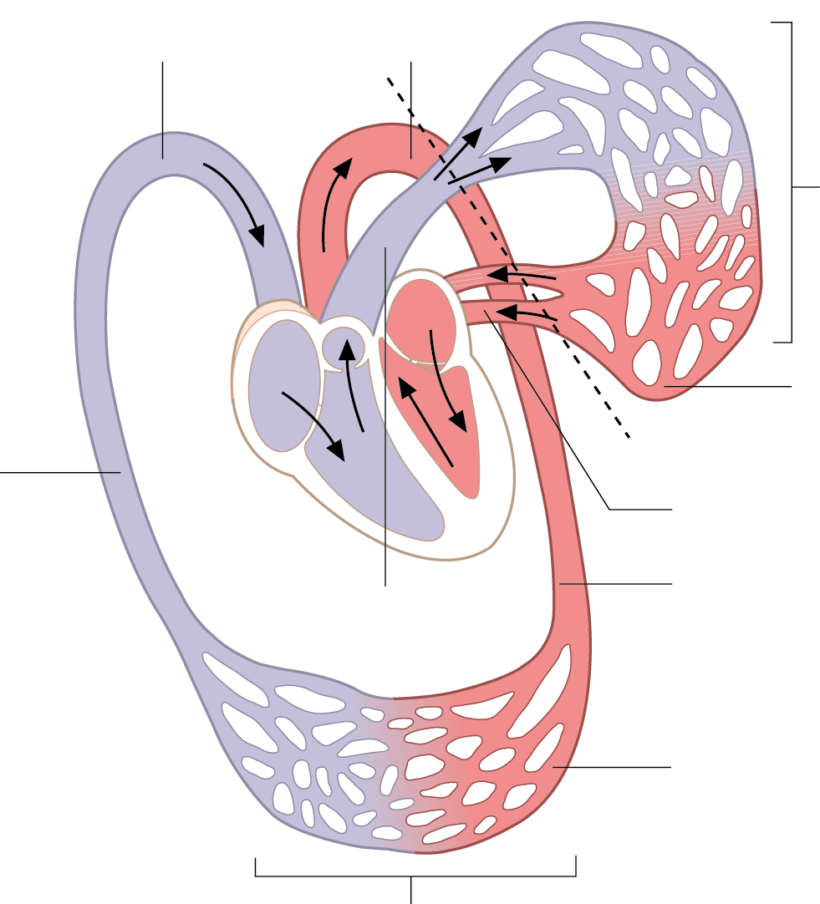

- Aorta
- Arteries / Arterioles
- Body
- Capillaries of the body
- Capillaries of the lungs
- Lungs
- Pulmonary artery
- Pulmonary vein
- Veins / venuoles
- Vena cava

Explain why on the diagram above is half of the system red and half blue? What type of blood vessel will the blue and red blood be in? Are there any exceptions to this rule?

Identify 3 medical conditions that can affect the circulatory system?

Explain what lifestyle factors could cause these conditions and what treatment might they need to help fix or reverse this condition.

Within Level 3 Health and Social Care you will cover many different aspects, these include;

- Human Lifespan Development
- Working in Health and Social Care
- Anatomy and Physiology
- Current Research into Health and Social Care
- Principles of Safe Practice
- Psychological Perspectives
- Sociological Perspectives
- Nutritional Health and Wellbeing
- & More!!!!

Websites for support with activities:

https://www.healthcareers.nhs.uk/

https://www.jobs.nhs.uk/

https://www.gov.uk/government/organisations/public-health-england

https://www.bbc.co.uk/bitesize/guides/z27nqhv/revision/5

https://kidshealth.org/en/teens/heart.html

https://www.livescience.com/22486-circulatory-system.html

https://www.nhsinform.scot/illnesses-and-conditions/heart-and-blood-vessels/about-the-heart/understanding-how-your-heart-functions

https://www.nhs.uk/conditions/cardiovascular-disease/

Hoping you enjoy these activities and we look forward to meeting you all in September!!

